**Ideation Phase**

**Define the Problem Statements**

|  |  |
| --- | --- |
| Date | 25 June 2025 |
| Team ID | LTVIP2025TMID31802 |
| Project Name | Citizen AI |
| Maximum Marks | 2 Marks |

**Customer Problem Statement Template:**

Create a problem statement to understand your customer's point of view. The Customer Problem Statement template helps you focus on what matters to create experiences people will love.

A well-articulated customer problem statement allows you and your team to find the ideal solution for the challenges your customers face. Throughout the process, you’ll also be able to empathize with your customers, which helps you better understand how they perceive your product or service.

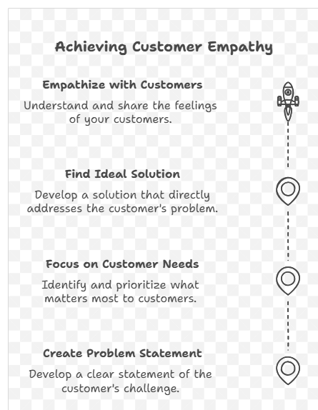

Reference: <https://miro.com/templates/customer-problem-statement/>

**Example:**

**Problem Statements**

**PS-1: Citizen Perspective**

I am a citizen who frequently needs information about government services and civic processes.  
I'm trying to get quick, reliable answers online without needing to visit a government office physically.  
But most government websites are outdated, unresponsive, or too complex to navigate. They often lack clear communication, and don't provide personalized help.  
Which makes me feel frustrated, ignored, and distrustful of digital governance systems. I often give up or rely on unofficial sources, which may provide inaccurate information.  
  
Citizen AI addresses this by offering a real-time AI-driven chatbot that understands context and provides fast, accurate, and relevant responses using natural language. It eliminates the need to manually search through bureaucratic websites and empowers citizens to get the help they need anytime, anywhere.

**PS-2: Government Official Perspective**

I am a government official responsible for monitoring citizen satisfaction and identifying systemic service gaps.  
I'm trying to understand the public's sentiment and pinpoint issues with service delivery in real-time so I can take timely corrective action.  
But there is no centralized tool that provides structured, aggregated feedback from citizens across different services. Feedback is scattered, unquantified, and difficult to interpret.  
Which makes me feel disconnected from public concerns and slow to act on critical issues, leading to declining trust in government effectiveness.  
  
Citizen AI solves this by integrating a sentiment analysis engine that categorizes feedback as Positive, Neutral, or Negative. The results are visualized in a dynamic dashboard, helping officials monitor trends, track concerns over time, and prioritize interventions. This not only enhances responsiveness but also supports data-driven governance.

These problem statements help align the technical development of Citizen AI with real-world needs and enable a user-centered approach from ideation through implementation.